D | C | B | A | OA
0 | 0 | 0 | 0 | 0
0 | 0 | 0 | 1 | 0
0 | 0 | 1 | 0 | 1
0 | 0 | 1 | 1 | 1
0 | 1 | 0 | 0 | 0
0 | 1 | 0 | 1 | 1
0 | 1 | 1 | 0 | 1
0 | 1 | 1 | 1 | 1
1 | 0 | 0 | 0 | 1
1 | 0 | 0 | 1 | 0
1 | 0 | 1 | 0 | 0
1 | 0 | 1 | 1 | 0
1 | 1 | 0 | 0 | 0
1 | 1 | 0 | 1 | 1
1 | 1 | 1 | 0 | 0
1 | 1 | 1 | 1 | 1
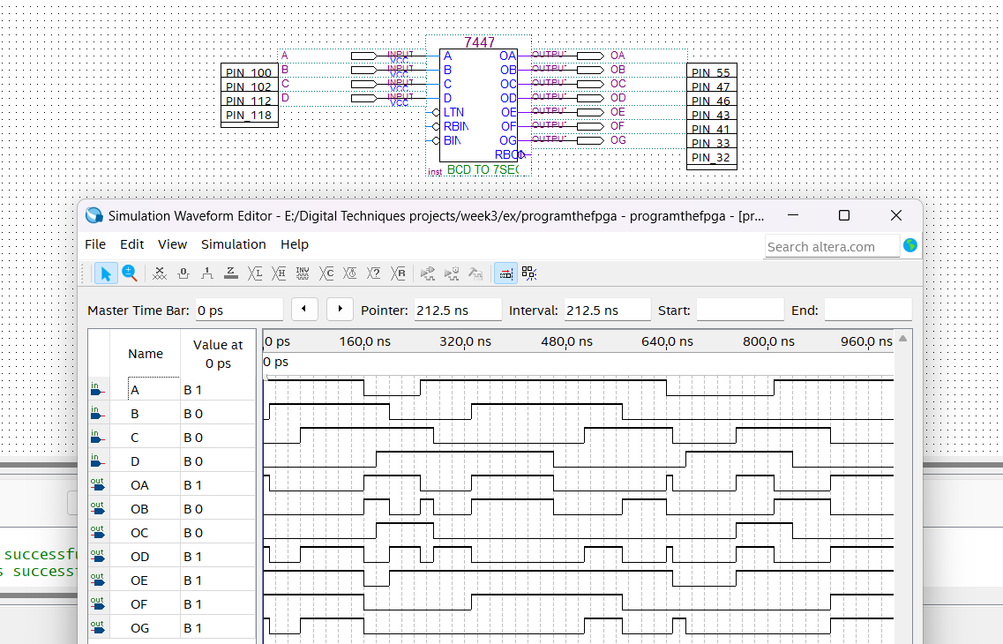
DC/BA | 00 | 01 | 11 | 10
00 | 0 | 0 | 1 | 1
01 | 0 | 1 | 1 | 1
11 | 0 | 1 | 1 | 0
10 | 1 | 0 | 0 | 0

FORMULA:
$D\overline{C}\overline{B}\overline{A} +CA+\overline{D}$B
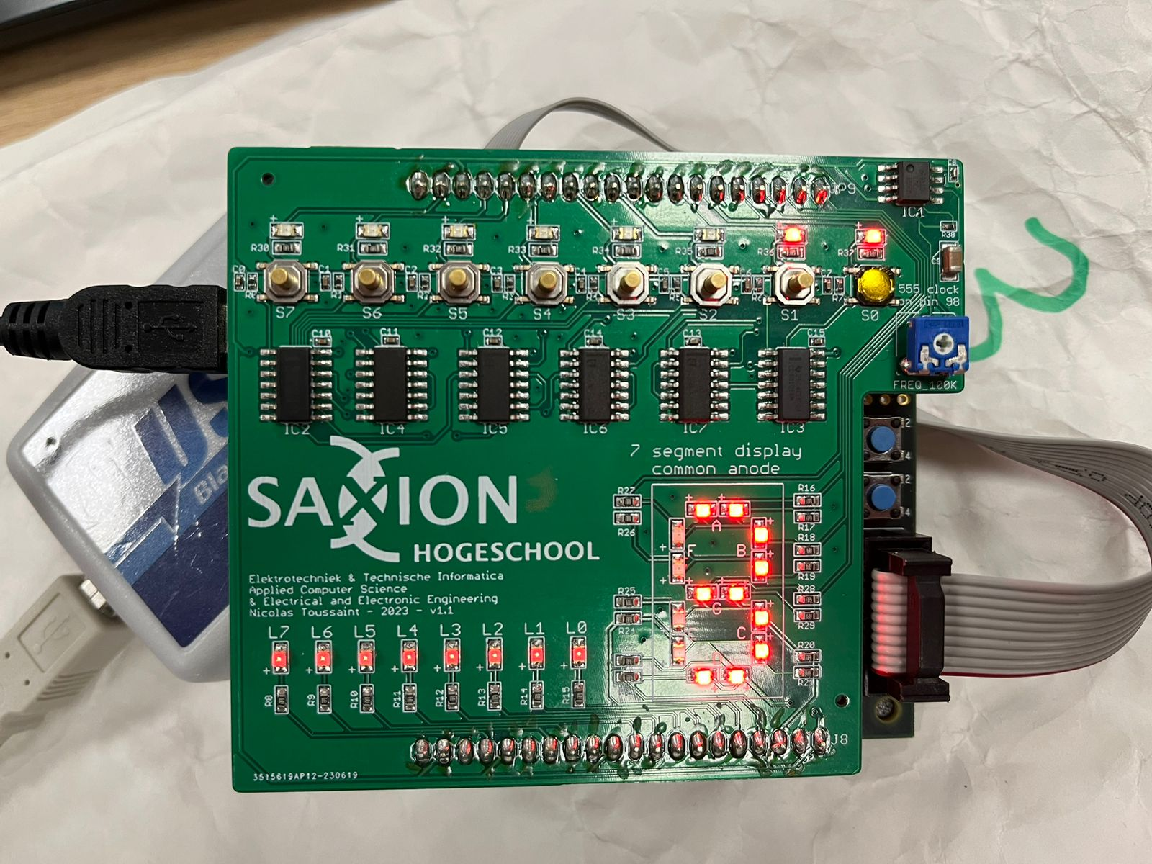 S3 - S0 (0011)
The inputs are Binary (0011) which are then converted into Decimal as number 3 displayed by the LED.

